I made a Folder in Local Disk E and rename as Github Project

My Folder was empty . There is no Hidden file in my folder

1. **git config --global user.email “OmaisAkhtarBSE010” && user.name “OmaisAkhtarBSE010”**

git config --global user.email & user.name command is used for config the setting

who coder work on it.

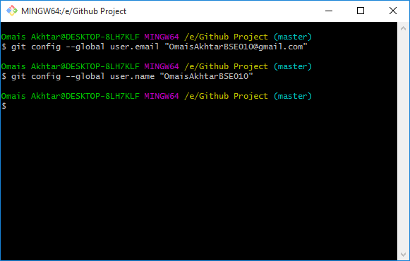

1. **CD E:**

CD (Change Directory ) is used for change location from one point to another.

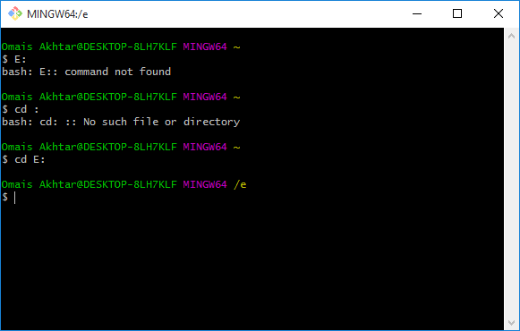

1. **ls**

LS (Lists Show) is used for show list of folder on the screen.

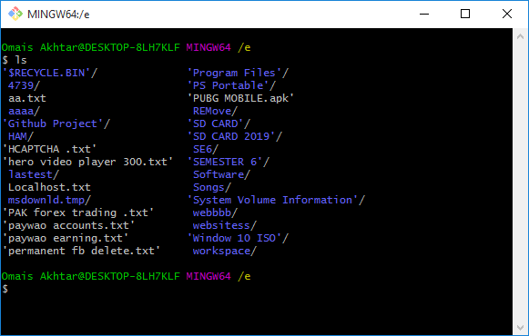

Now I goto Folder Github Project using mouse and check . is there any files or not ?

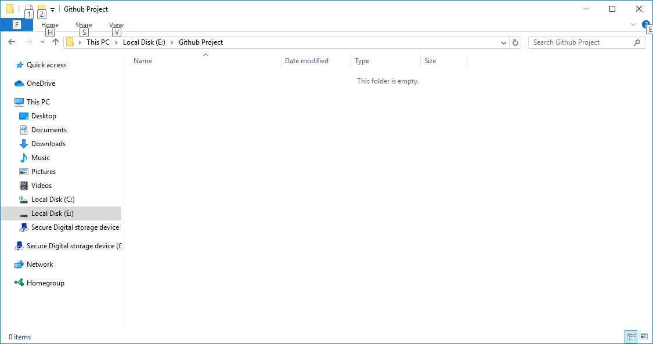

There is no hidden folder in my Folder.

1. **git init**

When git init is used and .git folder has created. Its mean that all the file and folder ,

Change its content .git folder catch it. I think.

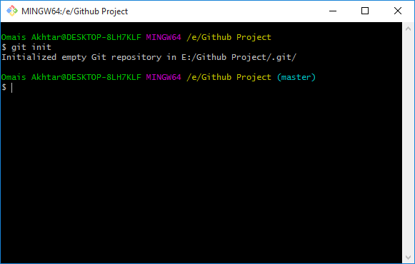

Now Again goto folder and check . is any file or folder existed or not ?

What I see ?

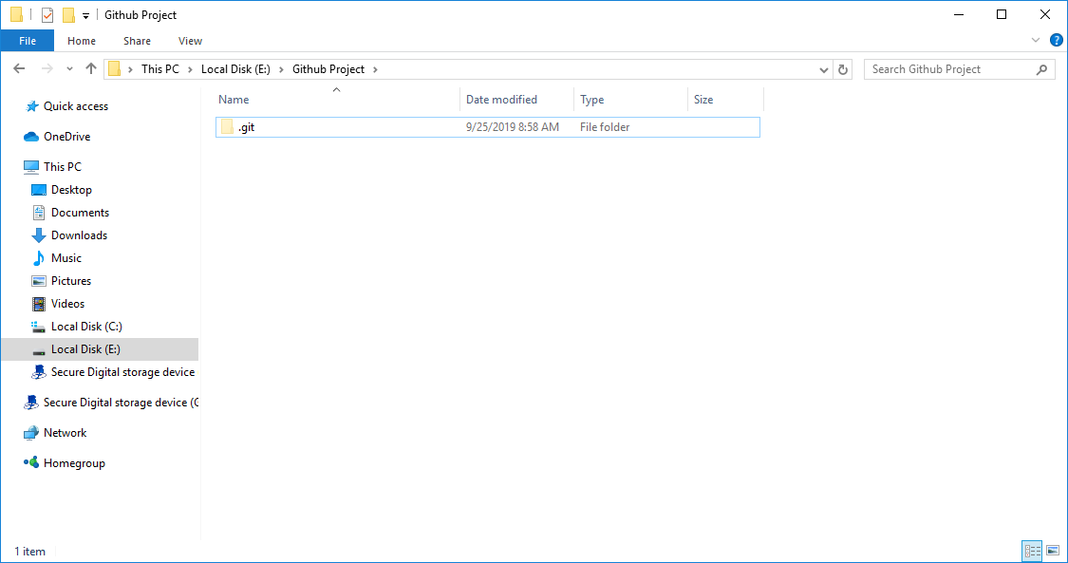

There is folder named .git . I don’t know why its come.

1. **git clone https://github.com/libgit2/ligbit2**

git clone “URL” is used for downloading / copying project from server to local machine.

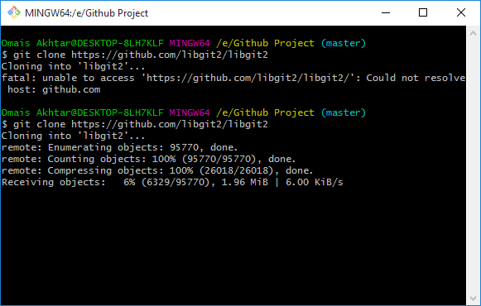

Now i have check the folder and what i see.??

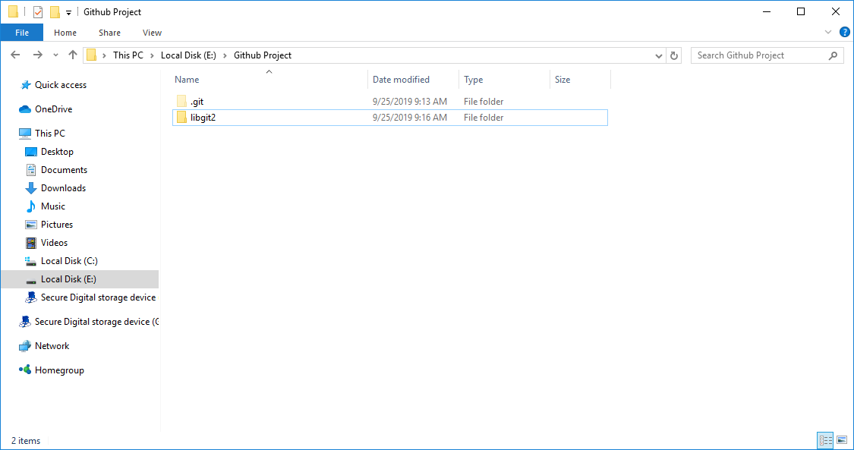

There is another folder name gitlib2 that i already downloaded from previous command.

1. **git clone** [**https://github.com/libgit2/ligbit2**](https://github.com/libgit2/ligbit2) **abc**

This is also used for downloading / copying data from server to local machine. But downloaded data are in FOLDERNAME.

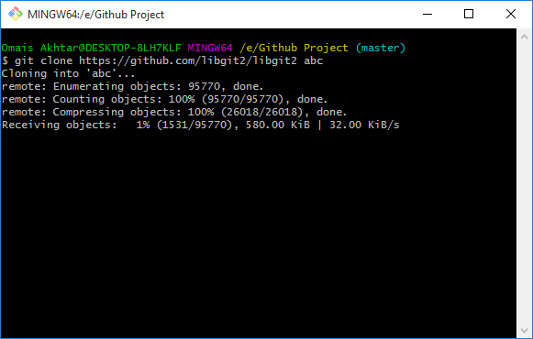

Now i check the folder . what i see . there is a folder name abc

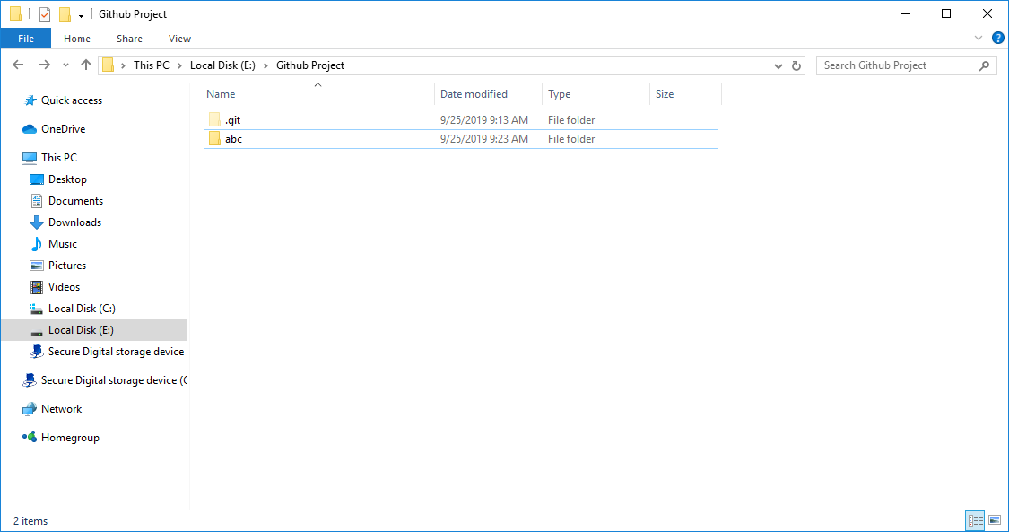

1. **git add index.html OR git add -A (For All Files)**

git add command is used for adding file to staging area. Before added, git don’t know about any files in the Folder..

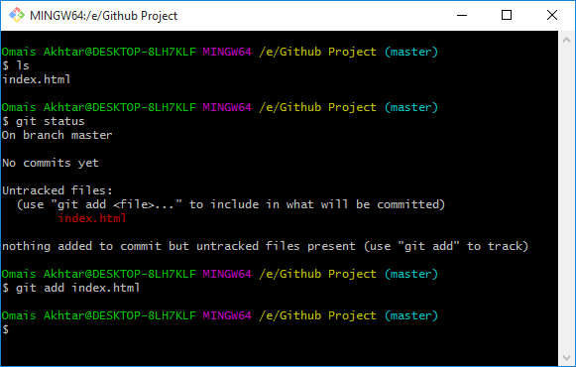

1. **git commit -m “Added Index.html”**

git command is used to promote or stag change to the project that stored in a commit

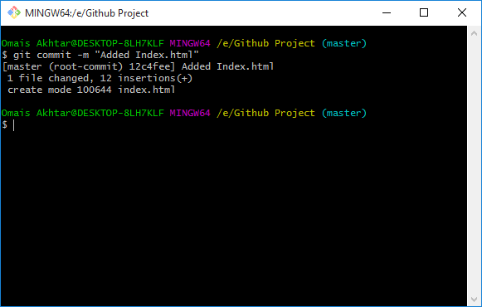

1. **git remote add orginal https://github.com/OmaisAkhtarBSE010/Software_Construction.git**

git remote add origin command is used to only link your repository to remote Server repository.

I have already checked the command therefore i receive a error msg.

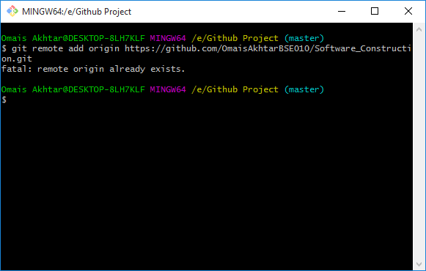

1. **git push origin master**

This command is used to push / store current repository to the remote Server repository.

At first time, its will ask you to sign in your Account in Github.

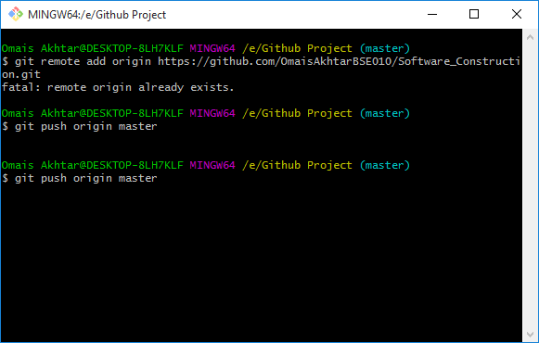

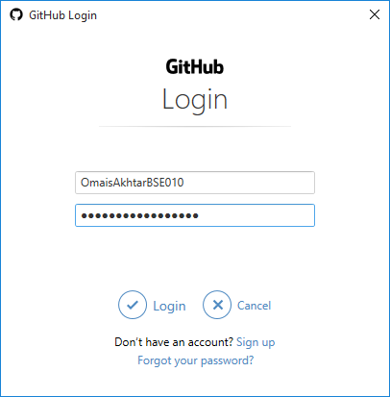

After Sign in , I have successfully MSG like this

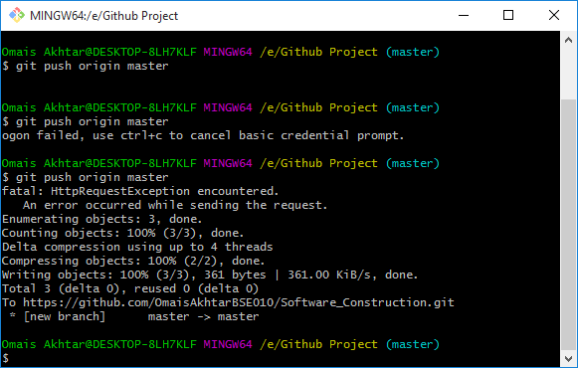

Then I checked my repository what I see ??

